MYSQL Project
Hospital Patient Management System

Project Description: The Hospital Patient Management System is designed to track a patient’s complete journey inside a hospital—from appointment scheduling to diagnosis, treatment, and billing.
The project helps the hospital administration improve:
- Operational efficiency
- Doctor workload management
- Department performance
- Treatment duration analysis
- Billing and payment tracking
This project mimics how real hospitals store and analyze data to ensure safety, reduce wait times, and optimize resources.

Database Tables (ER Structure)
The project contains 7 tables:
- departments – hospital departments
- doctors – doctor details
- patients – patient demographics
- appointments – appointment scheduling
- diagnosis – patient medical diagnosis
- treatments – treatment timeline
- billing – billing and payment status

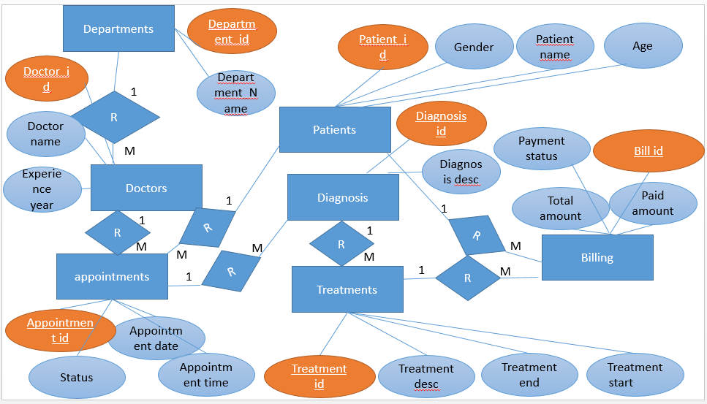

Queries
- Retrieve the complete list of all patients.

- Retrieve the complete list of all doctors.

- Display all the departments available in the hospital.

- Fetch all appointments that have been marked as 'Completed'.

- Find all patients whose age is greater than 40 years.

- Count the total number of doctors in the hospital.

- Retrieve all patients whose gender is 'Male'.

- Fetch all appointments scheduled on the date '2024-11-01'.

- List all diagnosis records available in the system.

- Retrieve all bills where the payment status is 'Unpaid'.

- Count the number of patients grouped by gender.

- Find the total number of appointments handled by each doctor.

- Calculate the total revenue collected from all patients.

- Determine the treatment duration (in days) for every patient.

- Calculate the total billing amount generated per patient.

- Display doctor names along with the departments they belong to.

- Fetch all appointments along with the respective patient and doctor names.

- List all patients along with their medical diagnosis details.

- Calculate the total number of patients treated in each department.

- Determine the average cost of all treatments administered.

- Retrieve the complete journey of each patient from appointment to billing.

Join all tables

- Find the average treatment duration for each department.

- Rank doctors based on the number of appointments they have handled.

- Identify the patients who have spent the highest total amount on treatment.

- Find the patient who had the longest treatment duration.

- Identify the doctor who generated the highest treatment revenue.

- Determine the most frequently occurring diagnosis.

- List all patients who still have pending dues.

- Find the patient who has booked the maximum number of appointments.

- Generate the daily revenue report based on payment records

